**Urban agriculture business guide**

**Specifications**

|  |
| --- |
| **Summary** |
| This document provides general business and technical information about “Urban agriculture business guide” project. |

**Record of revisions**

|  |  |  |  |  |
| --- | --- | --- | --- | --- |
| **Issue** | **Date** | **Major/Minor** | **Modified Part** | **Description of Change** |
| 1.0 | 10/12/2016 | Major | All | Document creation |

**Reference documents**

|  |  |
| --- | --- |
| **Reference** | **Document Title** |
| <http://driaaf.ile-de-france.agriculture.gouv.fr/IMG/pdf/187522149_Mon_projet_d_agriculture_urbaine_en_IdF_cle8b12dd_cle88256b.pdf> | Mon projet d’agriculture urbaine en Île-de-France.  Guide pratique d’information et d’orientation |
| <http://document.leefmilieu.brussels/opac_css/elecfile/etude_agricultureUrbaine_viabilite_Greenloop_avril2013.PDF?langtype=2067> | Etude sur la viabilité des business modèles en agriculture urbaine dans les pays du Nord |

Table of Contents

1 Purpose 4

2 Scope 4

3 Business Goals 4

4 Terminology 5

5 Methodology used for solution building 6

6 Requirements 7

7 Solution conceptual design 7

7.1 Model UML Class diagram 8

7.2 Process state diagram 9

8 Technical description 9

9 Illustration Table 11

# Purpose

The goal of this document is to:

* provide general information about the business goals of the project;
* provide technical information about the used technologies.

# Scope

Urban agriculture, urban farming or urban gardening is the practice of cultivating, processing, and distributing [food](https://en.wikipedia.org/wiki/Food) in or around a village, town, or city. Urban agriculture can also involve [animal husbandry](https://en.wikipedia.org/wiki/Animal_husbandry), [aquaculture](https://en.wikipedia.org/wiki/Aquaculture), [agroforestry](https://en.wikipedia.org/wiki/Agroforestry), [urban beekeeping](https://en.wikipedia.org/wiki/Urban_beekeeping), and [horticulture](https://en.wikipedia.org/wiki/Horticulture). These activities occur in [peri-urban](https://en.wikipedia.org/wiki/Peri-urban) areas as well, and [peri-urban agriculture](https://en.wikipedia.org/wiki/Peri-urban_agriculture) may have different characteristics.

Urban agriculture can reflect varying levels of economic and social development. In the global north, it often takes the form of a social movement for sustainable communities, where organic growers, ‘foodies,’ and ‘[locavores](https://en.wikipedia.org/wiki/Locavore" \o "Locavore)’ form social networks founded on a shared ethos of nature and community holism. These networks can evolve when receiving formal institutional support, becoming integrated into local town planning as a ‘transition town’ movement for sustainable urban development. In the developing south, [food security](https://en.wikipedia.org/wiki/Food_security), nutrition, and income generation are key motivations for the practice. In either case, more direct access to fresh vegetables, fruits, and meat products through urban agriculture can improve food security and [food safety](https://en.wikipedia.org/wiki/Food_safety).

# Business Goals

The idea of the project is to help people to build their own urban agriculture business. The first thing to do is to have a clear idea of what is possible to do, and how is it possible to do it. These first steps are very important: A clear and precise idea on the most appropriated business at the very beginning avoid future fruitless investment and waste of time and energy.

The main goal of the project is to provide a clear process to start a business in the best conditions.

Following main aspects have to be considered regarding the target location(s) of the installation(s):

* Business opportunities regarding the global market (business case)
* The climatic constraints (it is determining the applicable type of production)
* The administrative constraints (business official declaration …)
* The commercial constraints (be sure that the commercialization of target product(s) is possible from a legal point of view)
* The security constraint (particularly in you plan to build at least an installation on a building roof)
* The logistic constraints (particularly in you plan to build at least an installation on a building roof)

Another goal of the project is to provide business data coming from the global market of urban agriculture business. The best way to have a clear and precise idea on the business opportunities is to have access to the data (general data from a business point of view) of the business in the target business scope.

# Terminology

| Term / acronym | Meaning |
| --- | --- |
| CSS | Cascading Style Sheets |
| EJB | Entreprise Java Bean |
| HTML | HyperText Markup Language |
| J2EE | Java 2 Platform, Enterprise Edition |
| JSP | Java Server Pasges |
| MDE | Model Driving Engineering |
| MVC | Model View Controller |
| UML | Unified Modeling Language |

# Methodology used for solution building

As a software engineer claiming to respect the state of the art in model driven engineering, I used an academic way to build the prototype.

It is a way to highlight the good practises, and to denunciate bad and low level of software engineering practises used in a lot of IS companies… You guess that for sure, I already faced this practises, and now I want here to show what I am able to do, and not what other persons may impose me to do.

It is also a way to honour my initial formation, and particularly to honour Franck Barbier (<http://barbier.perso.univ-pau.fr/>), the man who introduced me the passion of model driven engineering. It was 10 years ago, I did the most interesting works in informatics with that person by going deep in details in UML and MDE, J2EE, EJB, especially when working on the migration of an ATM Bank system from simple jdbc model to an advanced pure EJB model (not spring or hibernate but directly pure EJB, which is very more complex and is considered as the top level of what is possible to do in object oriented technologies!)

So, here is the academic way I followed:

1. Gather information about what is urban agriculture and how to build his own business: The main sources used are previously referenced in the reference table (p.2)
2. Design the data model using UML class diagram: This model will be used to gather information from the global market of urban agriculture business
3. Design a sequence diagram to modelize the different steps to follow to start your own business
4. Build the prototype

The prototype has been realized. Please refer to the section *Technical description* to find more technical details.

Now, the final solution is in development phase.

# Requirements

Following table give the list of the requirements to satisfy:

|  |  |
| --- | --- |
| REQ ID | Requirement |
| RF01 | The architecture must respect a Model View Controller (MVC) structure |
| RF02 | The view design must be accessible from any device and the design must adapt to any device |
| RF03 | The very last technologies in term of persistence must be used |
| RF04 | The very last technologies in term of view design must be used |

# Solution conceptual design

In this section you will find conceptual information about the prototype building.

## Model UML Class diagram

Following pictures is the database UML diagram.

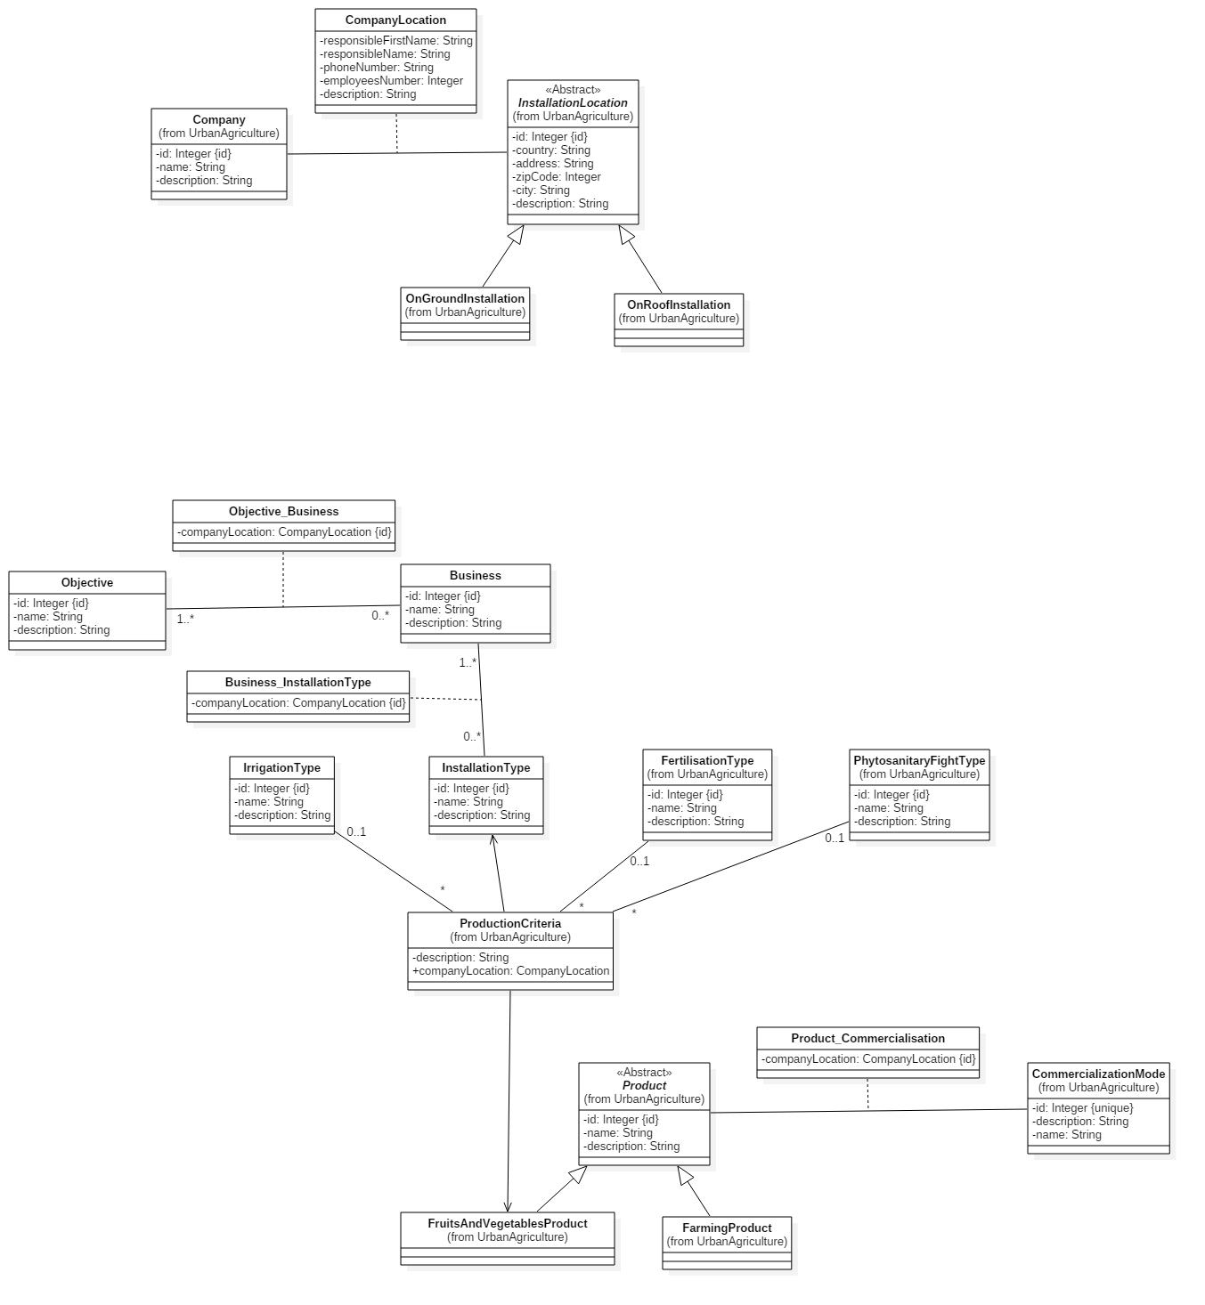

*Figure 1: Model UML Class diagram*

There is no receivable reason for the moment to give detailed tables for each entity. It would be maybe the case letter in an industrial context of the solution.

## Process state diagram

Building in progress…

# Technical description

Following table is the technical answer of the requirements provided in section *Requirements*.

|  |  |
| --- | --- |
| REQ ID | Technical answer |
| RF01 | A Spring Web MVC architecture has been used. It is composed of following items:   * Model packages (each package contained is own classes):   + Entities package   + DAO package (Data Access) composed of:     - A package for the DAO interfaces     - A package for the DAO implementations   + Services packages (services exposed to the controllers and using DAOs) * View directory:   + Last web responsive technologies has been implemented:     - HTML 5 / JSP     - CSS 3     - Bootstrap resolving the adaptation to any device without managing specific code for each device ☺ * Controller package:   + Contains the classes to do the link between the model and the view |
| RF02 | As previously said as an answer to the RF01 requirement, last web responsive technologies have been implemented. Bootstrap is responsible to manage the support to all devices. |
| RF03 | Here is the list of libraries used for the persistence:   |  |  | | --- | --- | | Library | version | | Java | 1.8 | | Hibernate | 5.2.4 | | Mysql | 5.7 | | MySQL connector | 6.0.5 | |
| RF04 | As previously said as an answer tor RF01:   * Last web responsive technologies has been implemented:   + HTML 5 / JSP   + CSS 3   + Bootstrap   Others libraries used:   |  |  | | --- | --- | | Library | version | | Jstl | 1.2 | | javax.servlet.jsp | 2.2 | | Mysql | 5.7 | |  |  | |

For information, here is a list of the other libraries used:

* Maven 1.8
* Tomcat 9.0
* Sl4j 1.7.21 (upper layer of logging frameworks, used as an abstraction of whatever in term of logging framework you want to use (log4j or others…)

# Illustration Table

Figure 1: Chronos interface description 8